* + memoizing selectors

VD:

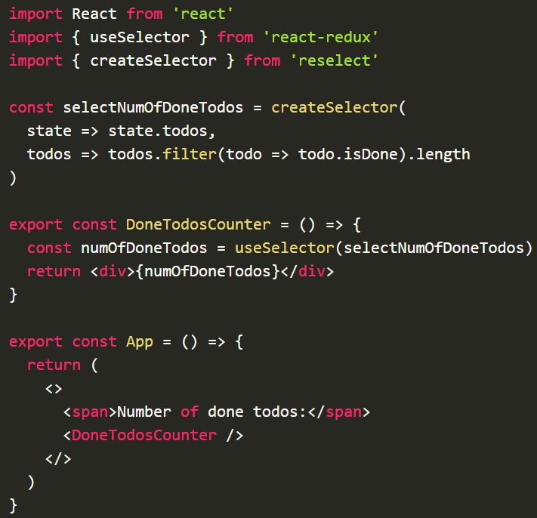

<https://github.com/reduxjs/reselect>

<https://blog.isquaredsoftware.com/2017/12/idiomatic-redux-using-reselect-selectors/>

* **Reference**